**Add Python to the PATH Environmental Variable (‘python’ is not recognized as an internal or external command)**

Step 1: Download Python

First visit the [official Python download page](https://www.python.org/download/releases/) and download the latest release. At the time of this writing the latest versions are 3.3.0.

Install it by double clicking the Python installer setup file and follow the wizard along.

Step 2: Add Python to the PATH Environmental Variable

Next, let's click on the **Start Menu** and right click *My Computer*. Click on *Advanced System Settings*.

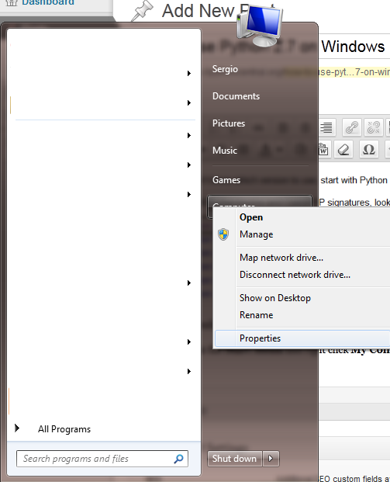

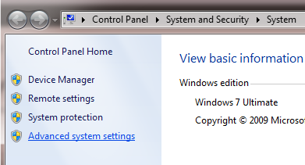

Then click on *Environment Variables*. This is where we can add Python to the PATH environmental variable.

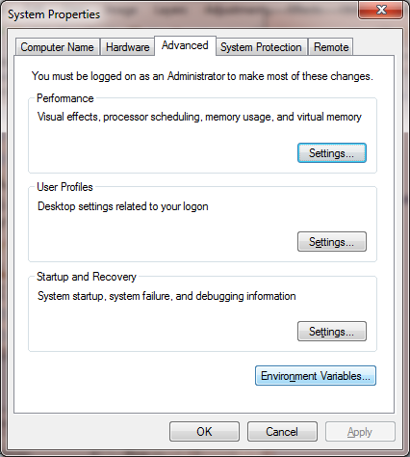

Find the PATH variable and click **Edit**. You want to add Python to this PATH variable by adding *;C:\Python27* to the end of that string (or whatever the path to your Python installation is).

Save your changes!

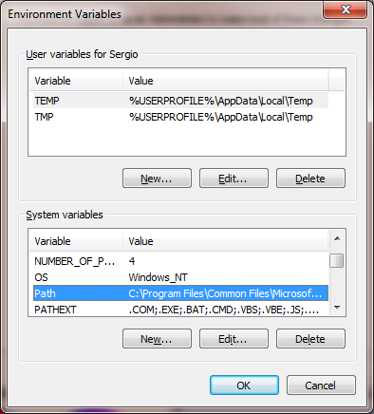

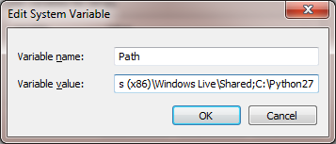

So what exactly is happening here?

When you type in python in a command prompt, Windows will use the PATH environmental variable to get a list of directories to go looking for the *python.exe* file. Before you followed the steps here, it couldn’t find the *python.exe* file, hence the error.

Now that the PATH variable is set, when you execute python via the Windows console, you'll see a familiar programming prompt.

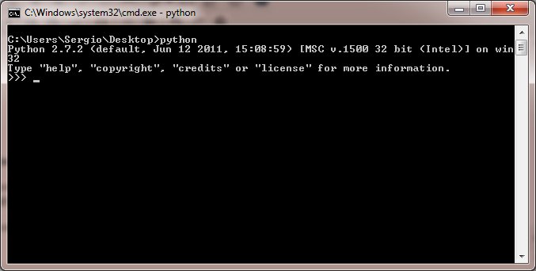

Python running on Windows!